Date: July 2014

NOTE: This is work in progress. It is not ready for review or use.

UML Profile for the Global Justice Information Sharing Initiative Global Reference Architecture (GRA-UML)

Version 0.23

__________________________________________________
OMG Document Number: gov/2014-??-??
Normative reference: http://www.omg.org/spec/gra-uml/1.0/
Machine readable file(s): http://www.omg.org/gra-uml/2014MMNN
Normative: http://www.omg.org/spec/gra-uml/2014MMNN/foo.xmi
Non-normative: http://www.omg.org/spec/gra-uml/2014MMNN/non_normative_foo.xmi
__________________________________________________

Copyright © 2014, IJIS
Copyright © 2014, Model Driven Solutions
Copyright © 2014, Object Management Group, Inc.

USE OF SPECIFICATION - TERMS, CONDITIONS & NOTICES
The material in this document details an Object Management Group specification in accordance with the terms, conditions and notices set forth below. This document does not represent a commitment to implement any portion of this specification in any company's products. The information contained in this document is subject to change without notice.

LICENSES
The companies listed above have granted to the Object Management Group, Inc. (OMG) a nonexclusive, royalty-free, paid up, worldwide license to copy and distribute this document and to modify this document and distribute copies of the modified version. Each of the copyright holders listed above has agreed that no person shall be deemed to have infringed the copyright in the included material of any such copyright holder by reason of having used the specification set forth herein or having conformed any computer software to the specification.
Subject to all of the terms and conditions below, the owners of the copyright in this specification hereby grant you a fully-paid up, non-exclusive, nontransferable, perpetual, worldwide license (without the right to sublicense), to use this specification to create and distribute software and special purpose specifications that are based upon this specification, and to use, copy, and distribute this specification as provided under the Copyright Act; provided that: (1) both the copyright notice identified above and this permission notice appear on any copies of this specification; (2) the use of the specifications is for informational purposes and will not be copied or posted on any network computer or broadcast in any media and will not be otherwise resold or transferred for commercial purposes; and (3) no modifications are made to this specification. This limited permission automatically terminates without notice if you breach any of these terms or conditions. Upon termination, you will destroy immediately any copies of the specifications in your possession or control.

PATENTS
The attention of adopters is directed to the possibility that compliance with or adoption of OMG specifications may require use of an invention covered by patent rights. OMG shall not be responsible for identifying patents for which a license may be required by any OMG specification, or for conducting legal inquiries into the legal validity or scope of those patents that are brought to its attention. OMG specifications are prospective and advisory only. Prospective users are responsible for protecting themselves against liability for infringement of patents.

GENERAL USE RESTRICTIONS
Any unauthorized use of this specification may violate copyright laws, trademark laws, and communications regulations and statutes. This document contains information which is protected by copyright. All Rights Reserved. No part of this work covered by copyright herein may be reproduced or used in any form or by any means--graphic, electronic, or mechanical, including photocopying, recording, taping, or information storage and retrieval systems--without permission of the copyright owner.

DISCLAIMER OF WARRANTY
WHILE THIS PUBLICATION IS BELIEVED TO BE ACCURATE, IT IS PROVIDED "AS IS" AND MAY CONTAIN ERRORS OR MISPRINTS. THE OBJECT MANAGEMENT GROUP AND THE COMPANIES LISTED ABOVE MAKE NO WARRANTY OF ANY KIND, EXPRESS OR IMPLIED, WITH REGARD TO THIS PUBLICATION, INCLUDING BUT NOT LIMITED TO ANY WARRANTY OF TITLE OR OWNERSHIP, IMPLIED WARRANTY OF MERCHANTABILITY OR WARRANTY OF FITNESS FOR A PARTICULAR PURPOSE OR USE. IN NO EVENT SHALL THE OBJECT MANAGEMENT GROUP OR ANY OF THE COMPANIES LISTED ABOVE BE LIABLE FOR ERRORS CONTAINED HEREIN OR FOR DIRECT, INDIRECT, INCIDENTAL, SPECIAL, CONSEQUENTIAL, RELIANCE OR COVER DAMAGES, INCLUDING LOSS OF PROFITS, REVENUE, DATA OR USE, INCURRED BY ANY USER OR ANY THIRD PARTY IN CONNECTION WITH THE FURNISHING, PERFORMANCE, OR USE OF THIS MATERIAL, EVEN IF ADVISED OF THE POSSIBILITY OF SUCH DAMAGES.
The entire risk as to the quality and performance of software developed using this specification is borne by you. This disclaimer of warranty constitutes an essential part of the license granted to you to use this specification.

RESTRICTED RIGHTS LEGEND
Use, duplication or disclosure by the U.S. Government is subject to the restrictions set forth in subparagraph (c) (1) (ii) of The Rights in Technical Data and Computer Software Clause at DFARS 252.227-7013 or in subparagraph (c)(1) and (2) of the Commercial Computer Software - Restricted Rights clauses at 48 C.F.R. 52.227-19 or as specified in 48 C.F.R. 227-7202-2 of the DoD F.A.R. Supplement and its successors, or as specified in 48 C.F.R. 12.212 of the Federal Acquisition Regulations and its successors, as applicable. The specification copyright owners are as indicated above and may be contacted through the Object Management Group, 140 Kendrick Street, Needham, MA 02494, U.S.A.

TRADEMARKS
MDA®, Model Driven Architecture®, UML®, UML Cube logo®, OMG Logo®, CORBA® and XMI® are registered trademarks of the Object Management Group, Inc., and Object Management Group™, OMG™ , Unified Modeling Language™, Model Driven Architecture Logo™, Model Driven Architecture Diagram™, CORBA logos™, XMI Logo™, CWM™, CWM Logo™, IIOP™ , IMM™ , MOF™ , OMG Interface Definition Language (IDL)™ , and OMG SysML™ are trademarks of the Object Management Group. All other products or company names mentioned are used for identification purposes only, and may be trademarks of their respective owners.

COMPLIANCE
The copyright holders listed above acknowledge that the Object Management Group (acting itself or through its designees) is and shall at all times be the sole entity that may authorize developers, suppliers and sellers of computer software to use certification marks, trademarks or other special designations to indicate compliance with these materials.
Software developed under the terms of this license may claim compliance or conformance with this specification if and only if the software compliance is of a nature fully matching the applicable compliance points as stated in the specification. Software developed only partially matching the applicable compliance points may claim only that the software was based on this specification, but may not claim compliance or conformance with this specification. In the event that testing suites are implemented or approved by Object Management Group, Inc., software developed using this specification may claim compliance or conformance with the specification only if the software satisfactorily completes the testing suites.

OMG’s Issue Reporting Procedure

All OMG specifications are subject to continuous review and improvement. As part of this process we encourage readers to report any ambiguities, inconsistencies, or inaccuracies they may find by completing the Issue Reporting Form listed on the main web page http://www.omg.org, under Documents, Report a Bug/Issue (http://www.omg.org/technology/agreement.)

Table of Contents

0 Submission-related material 0-I
0.1 Submission Introduction 0-I
0.2 Submission Team 0-I
0.2.1 Submitters 0-I
0.2.2 Government Stakeholders 0-I
0.2.3 Contributors 0-I
0.3 Resolution of Requirements 0-I
0.3.1 Mandatory requirements 0-I
0.3.2 Non-mandatory features 0-II
0.4 Resolution of Discussion Issues 0-II
1 Scope 1
1.1 GRA-UML Background 1
1.2 Intended Users of GRA-UML 1
1.3 GRA-UML Profile, Library and Transformations 1
2 Conformance 2
3 Normative References 2
4 Terms and Definitions 2
5 Symbols 3
6 Additional Information 3
6.1 Acknowledgements 4
7 GRA-UML Modeling Guide 5
7.1 GRA SSP Overview 5
7.2 Two-Phase SSP Provisioning 6
7.3 The Logical Service Profile 7
7.3.1 Actors 8
7.3.2 Use cases 8
7.3.3 Interfaces 9
7.3.4 Components and ports 9
7.3.5 Collaborations & Interactions 10
7.4 The GRA Annotation Library 11
7.4.1 Overview 11
7.4.2 Derived properties 11
7.4.3 Compositions 12
7.4.4 Service hierarchy defaults 12
8 GRA-UML Logical Services Profile 13
8.1 UML subset 13
8.2 Stereotypes 13
9 GRA Modeling Library 13
10 GRA-UML Transformations 13
10.1 SSP workflow and structure 13
10.2 Catalog.xml 13
10.3 Metadata.xml 13
10.4 Annotations.xmi 13
10.5 SDD 14
10.6 SIDD 14
10.7 WSDL 14
Annex A: GRA-UML Examples 15
Annex B: Mappings to other specifications 16
Annex C: Machine Readable Files 17
Annex D: Document revision history 18

Table of Figures
Figure 1 Mandatory SSP folder structure 5
Figure 2 Two-phase SSP provisioning 7
Figure 3 Actors 8
Figure 4 Use Cases 9
Figure 5 Interfaces 9
Figure 6 Components and Ports 10
Figure 7 Collaboration 10
Figure 8 Interactions 10

Preface
OMG
Founded in 1989, the Object Management Group, Inc. (OMG) is an open membership, not-for-profit computer industry standards consortium that produces and maintains computer industry specifications for interoperable, portable, and reusable enterprise applications in distributed, heterogeneous environments. Membership includes Information Technology vendors, end users, government agencies, and academia.
OMG member companies write, adopt, and maintain its specifications following a mature, open process. OMG’s specifications implement the Model Driven Architecture® (MDA®), maximizing ROI through a full-lifecycle approach to enterprise integration that covers multiple operating systems, programming languages, middleware and networking infrastructures, and software development environments. OMG’s specifications include: UML® (Unified Modeling Language™); CORBA® (Common Object Request Broker Architecture); CWM™ (Common Warehouse Metamodel); and industry-specific standards for dozens of vertical markets.
More information on the OMG is available at http://www.omg.org/.
OMG Specifications
As noted, OMG specifications address middleware, modeling and vertical domain frameworks. All OMG Specifications are available from the OMG website at:
http://www.omg.org/spec
Specifications are organized by the following categories:
Business Modeling Specifications
Middleware Specifications
- CORBA/IIOP
- Data Distribution Services
- Specialized CORBA
IDL/Language Mapping Specifications
Modeling and Metadata Specifications
- UML, MOF, CWM, XMI
- UML Profile
Modernization Specifications
Platform Independent Model (PIM), Platform Specific Model (PSM), Interface Specifications
- CORBAServices
- CORBAFacilities
OMG Domain Specifications
CORBA Embedded Intelligence Specifications
CORBA Security Specifications
All of OMG’s formal specifications may be downloaded without charge from our website. (Products implementing OMG specifications are available from individual suppliers.) Copies of specifications, available in PostScript and PDF format, may be obtained from the Specifications Catalog cited above or by contacting the Object Management Group, Inc. at:

OMG Headquarters
140 Kendrick Street
Building A, Suite 300
Needham, MA 02494
USA
Tel: +1-781-444-0404
Fax: +1-781-444-0320
Email: pubs@omg.org
Certain OMG specifications are also available as ISO standards. Please consult http://www.iso.org
Typographical Conventions
The type styles shown below are used in this document to distinguish programming statements from ordinary English. However, these conventions are not used in tables or section headings where no distinction is necessary.
Times/Times New Roman - 10 pt.: Standard body text
Helvetica/Arial - 10 pt. Bold: OMG Interface Definition Language (OMG IDL) and syntax elements.
Courier - 10 pt. Bold: Programming language elements.
Helvetica/Arial - 10 pt: Exceptions

NOTE: Terms that appear in italics are defined in the glossary. Italic text also represents the name of a document, specification, or other publication.

Issues

The reader is encouraged to report any technical or editing issues/problems with this specification to http://www.omg.org/report_issue.htm.

Submission-related material

Submission Introduction
The GRA-UML submission team is pleased to present an initial submission to the “UML Profile For GRA (GRA-UML)” Request for Proposal gov/13-09-20.
The IPR mode for this submission is Non-Assert.
Clause 0 of this document contains information specific to the OMG submission process and is not part of the proposed specification. The proposed specification starts with Clause 1. All clauses are normative unless otherwise specified.

Submission Team

Submitters
Cory Casanave, Model Driven Solutions, cory-c@modeldriven.com

Government Stakeholders
xxx, yyy, xxx@yyy.gov

Contributors
xxx, yyy, xxx@yyy.foo

Resolution of Requirements

Mandatory requirements
6.5.1 Submissions shall specify a GRA-UML Logical Profile. The GRA-UML Logical Profile shall be a set of UML stereotypes and properties which support the modeling of SSPs in UML in a technology-independent way. This profile shall support modeling of any content and structure allowed by GRA SSPs, while constraining the modeling of any content and structure disallowed by GRA SSPs, as specified in 6.5.4. The use of the GRA-UML Logical Profile shall result in UML models that are free from dependency on any physical representation (such as XML Schema). In MDA terms, the GRA Logical Profile is a specification of the platform independent model (PIM).
6.5.2 Submissions shall specify a GRA-UML Profile for SSPs. The GRA-UML Profile for SSPs shall be a set of UML stereotypes and properties which specify the details and metadata of a SSP specification to be produced based on logical GRA model(s). Transformations (discussed in 6.5.3) shall be designed to utilize the Profile for SSPs to parameterize the transformation from the GRA-UML Logical Profile (the PIM) to GRA-conformant SSPs (the PSM), where GRA conformance is as defined in 6.5.4. The SSP profile shall govern the inclusion in a UML model of any information necessary to properly generate GRA-conformant SSP artifacts beyond the information found in the GRA-UML Logical profile.
6.5.3 Submissions shall specify a transformation from UML models using the GRA-UML profiles specified in 6.5.1 and 6.5.2 to the set of artifacts required in a conformant SSP, as defined by 6.5.4. Submissions shall utilize the GRA-UML Profiles to model at least one existing GRA SSP and demonstrate the resulting transformation to an SSP. The SSP produced must be GRA conformant, as defined in section 6.5.4, and the XML Schema set contained within the SSP must validate the same set of exchange documents as the existing SSP IEPD. It is not required that the generated SSP be structurally identical to the existing SSP.
6.5.4 The SSPs generated based on models conforming to the GRA-UML profile shall conform to normative GRA specifications referenced in section 6.4.1. These specifications are:
• GRA Service Specification Package, v1.0.0 (http://it.ojp.gov/docdownloader.aspx?ddid=1217)
• GRA Service Specification Guideline v1.0.0 (http://it.ojp.gov/docdownloader.aspx?ddid=1215)
• GRA Web-Services Service Interaction Profile v1.3 (http://it.ojp.gov/docdownloader.aspx?ddid=1173)
• GRA ebXML Messaging Service Interaction Profile v1.1 (http://it.ojp.gov/docdownloader.aspx?ddid=1168)
• GRA Reliable Secure Web Services, Service Interaction Profile v1.2 (http://it.ojp.gov/docdownloader.aspx?ddid=1134)
6.5.5 Specifications shall reuse constructs and/or representations from SoaML to express the SSP logical model and will extend SoaML to meet specific requirements of the GRA where required.
6.5.6 Specifications shall reuse elements and/or representations from UML Profile for BPMN 2 Processes to express the SSP logical model and more specifically the SSP interaction model.
6.5.7 Specifications shall define mappings between GRA, and these industry-standard specifications - OMG SoaML, OASIS SOA-Reference Model, Open Group SOA Ontology. | TBD. Cory can do SoaML.
6.5.8 Specifications shall use OMG-QVT to specify the transformation of the UML logical model to all or part of a SSP.

Non-mandatory features
6.6.1 Submissions may specify a “reverse engineering” transformation from a GRA conformant SSP to UML models that conform to the GRA-UML profiles. The reverse engineering shall produce both a “PIM” (A model conforming to the GRA-UML Logical Profile) and a corresponding “PSM” (A model conforming to the GRA-UML Profile for SSPs) such that applying the forward engineering transformations to these models produces a GRA-conformant SSP semantically equivalent to the input.
6.6.2 The submitters may propose a revision of SoaML which would benefit GRA needs and the community at large. | No such revision is proposed. The GRA logical services profile is similar to a subset of SoaML but simpler and smaller.

Resolution of Discussion Issues
6.7.1 Submissions shall discuss the relationship of GRA-UML with other ongoing and related GRA standards, the existing GRA specifications and the GRA process.
Ask Ashwini.
6.7.2 Submissions shall discuss their relationship with other relevant standards including but not limited to the Unified Profile for DoDAF/MODAF (UPDM)
Defer to revised specification.
6.7.3 If a GRA SIP for the Representational State Transfer (REST) protocol becomes available during the submission process, submissions may discuss its impact on the submission.
No such SIP exists at present. The two-phase generation approach specified by GRA-UML should be able to incorporate such technology developments.
6.7.4 Submissions shall discuss their relationship with other relevant standards including but not limited to the IEPPV.
There is no substantive relationship with IEPPV. The policy approach specified by GRA-UML is aligned with GRA.

Scope

GRA-UML Background
The Global Reference Architecture (GRA) is an information exchange solution designed to reduce implementation time and costs for state and local justice agencies through reuse of established practices in IT architecture and design. It is developed and maintained under the governance of the Global Standards Council (GSC), part of the Global Justice Information Sharing Initiative (Global) which serves as a Federal Advisory Committee (FAC) and advises the U.S. Attorney General on justice information sharing and integration initiatives.
GRA solutions to information exchange are made up of a combination of the connection method (often Web Services), the exchange language (use of NIEM is encouraged), and the security specifications (encryption at the transport layer, data layer, etc.). These specifications are packaged into a GRA solution that can be customized to meet an individual organization’s needs. These packages are called Service Specification Packages (SSPs). A Service Specification Package Template and a number of reference Service Specification Packages are available as part of the GRA and can be found on the GRA website at http://www.it.ojp.gov/gra. The GRA SSPs are used by a number of justice and public safety agencies to define and implement interoperable information sharing services.
Prior to GRA-UML there were no standard based tools which could be used to model and generate GRA SSPs. As a result creating, reusing and implementing GRA SSPs was a very manual process, and requires comprehensive understanding of the GRA.
In GRA-UML, SSPs are generated from models, thus simplifying and improving the consistency of their implementation. The models are created from two viewpoints:
- The Logical Service Model is a platform-independent description of the services automated by the SSP.
- The Annotation Model is a description of the additional metadata needed to interpret the Logical Service Model and generate a complete valid SSP.
Each of these models is created using a subset of UML. GRA-UML defines these subsets together with the transformations and workflows used to generate a complete valid SSP from the models.

Intended Users of GRA-UML
GRA-UML enables the construction of an SSP to be distributed amongst architects and developers with different skillsets. The Logical Service Model specifies business requirements for the services, including the various participating individuals, organizations and software systems, the capabilities offered by these participants, and the interactions between them. These are modeled in a technology-agnostic way using a modest and well-defined subset of UML; the modelers need only understand this subset of UML and the business requirements to be modeled. The Annotation Model adds the detail required to generate the complete SSP. This includes technology and policy choices for the SSP, in cases where these choices cannot be inferred from the Logical Service Model by applying defaults. The annotation modeler needs a good understanding of the structure of SSPs and the various policy and implementation choices available. The final step in the production of an SSP involves the application of XSLT transformations to generate the actual SSP artifacts; these XSLT transformations may be customized by a template developer, expert in XSLT and in the target technology, in cases where the detailed implementation choices provided by the pre-packaged templates require changing.

GRA-UML Profile, Library and Transformations
A GRA-UML Logical Service Model is created using the Logical Services UML Profile described in Clause 8. This profile defines a subset of UML that includes SOA constructs such as Actors, Use Cases, Components, Ports, Interfaces etc., and two UML stereotypes, together with modeling conventions about how to use the profile to describe service participants and their interactions.
A GRA-UML Annotation Model is created by using the GRA Annotation Library described in Clause 8. Metadata describing the SSP requirements is created by instantiating types from the Annotation Library as UML InstanceSpecifications, linked together into a UML instance model that portrays the overall structure of the metadata for the SSP.
Given a Logical Services Model and Annotation Model, a two-phase provisioning process is used. First, QVT transformations are used to convert the models into a standardized intermediate format that provides all of the metadata needed to construct a complete valid SSP. Secondly, XSLT transformations are applied to create the final SSP artifacts.
Clause 7 is a modeling guide that provides a detailed rationale and description for each of these models, conventions, workflows and transformations.

Conformance
The Conformance clause identifies which clauses of the specification are mandatory (or conditionally mandatory) and which are optional in order for an implementation to claim conformance to the specification.
Note: For conditionally mandatory clauses, the conditions must, of course, be specified.

Normative References
The following normative documents contain provisions which, through reference in this text, constitute provisions of this specification. For dated references, subsequent amendments to, or revisions of, any of these publications do not apply.
[MOF] OMG Meta Object Facility (MOF) Core Specification v2.4.2, formal/2014-04-03, http://www.omg.org/spec/MOF/2.4.2/PDF/
[UML] OMG Unified Modeling Language (UML) Superstructure v2.4.1, formal/2011-08-06, http://www.omg.org/spec/UML/2.4.1/Superstructure/PDF/
[OCL] OMG Object Constraint Language (OCL) v2.4, formal/2014-02-03, http://www.omg.org/spec/OCL/2.4/PDF/
[QVT] OMG Meta Object Facility (MOF) Query/View/Transformation v1.2, ptc/2014-03-38, http://www.omg.org/spec/QVT/1.2/Beta/PDF
[GRA] Global Reference Architecture, https://it.ojp.gov/gra
[NIEM] National Information Exchange Model, www.niem.gov

Terms and Definitions
For the purposes of this specification, the following terms and definitions apply. For terms labelled (GRA), full definitions are found at https://it.ojp.gov/gist/43/The-Global-Reference-Architecture--GRA--Service-Specification-Guideline-V-1-0-0.
IEPD (NIEM)
Information Exchange Package Documentation.
LSM
Logical Service Model.
SOA
Service Oriented Architecture.
SDD (GRA)
Service Description Document.
SIDD (GRA)
Service Interface Description Document.
SSP (GRA)
Service Specification Package.
SIP (GRA)
Service Interaction Profile.
WSDL
Web Services Description Language, an XML-based interface definition language used for describing the functionality offered by a web service.
XHTML
Extensible HyperText Markup Language.

Symbols
There are no symbols defined in this specification.

Additional Information

Acknowledgements
The following entities have played a significant role in driving the development of this specification:
- Submitters
- Model Driven Solutions
- The Integrated Justice Information Systems Institute (IJIS)
- Government Stakeholders
- US Department of Justice
- Contributors
- Hidden Symmetry Ltd.
- Open Networks Inc.

GRA-UML Modeling Guide

GRA SSP Overview
The purpose of a GRA-UML tool is to enable GRA architects and developers to model the business and technological requirements for a GRA SSP using UML, and to provision the complete valid GRA SSP as an output. This section briefly describes the contents and structure of a GRA SSP: it is necessary to understand these in order to understand the process used to create them. Full details of the GRA SSP can be found at https://it.ojp.gov/gist/43/The-Global-Reference-Architecture--GRA--Service-Specification-Guideline-V-1-0-0.
The files that constitute a valid GRA SSP must be arranged in the predefined folder structure shown in Figure 1.
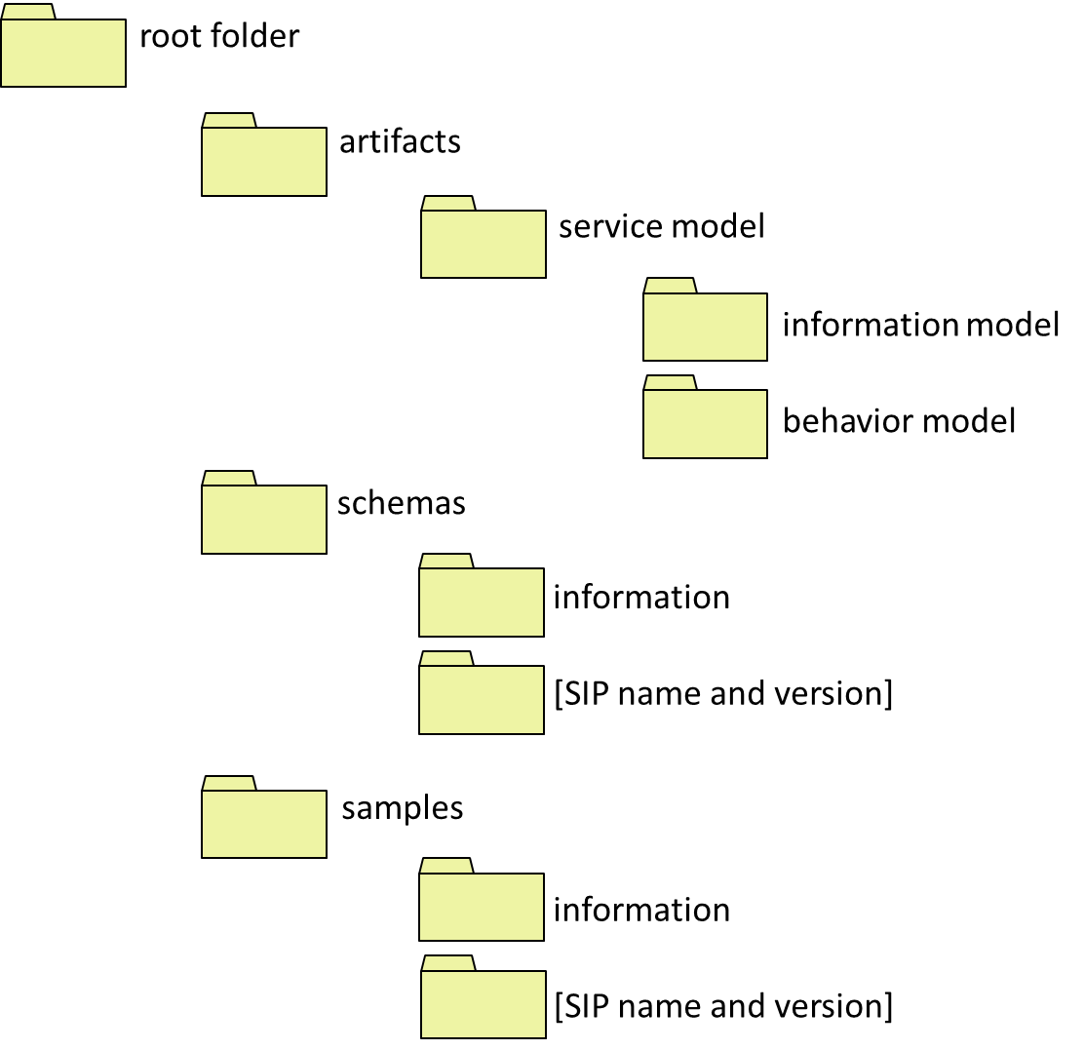
Figure 1 Mandatory SSP folder structure
A complete GRA SSP (Service Specification Package) comprises at least the following files:
- A Service Description, manifested in a Service Description Document (SDD). This is a human-readable file contained in the artifacts folder. For GRA-UML, XHTML format is generated.
- One or more Service Interface Descriptions, manifested in Service Interface Description Documents (SIDDs). Each Service Interface Description must conform to one or more Service Interaction Profiles (SIPs). SIDDs are human-readable files contained in the artifacts folder. For GRA-UML, XHTML format is generated.
- A Service Metadata file. This is called metadata.xml and contained in the root folder.
- A Service Catalog. This consists of two files, a machine-readable catalog.xml and a human-readable catalog.html, both contained in the root folder.
- A Service Specification Information Model, which must be a NIEM-conformant IEPD. This is packaged in a zip file or folder and contained in the artifacts/service model/information model folder.
- A Service Specification Behavior Model. In the case of GRA-UML, this is the Logical Service Model (see clause 7.3). It is contained in the artifacts/service model/behavior model folder.
- Schemas. Schemas from the IEPD that are used in the Service Specification are contained in the schemas/information folder. Web Service descriptions in WSDL format that are generated from the annotated GRA-UML model are contained in the schemas/[SIP name and version] folder, where the name of the folder corresponds to the SIP used to generate the WSDL.
Other optional files may be included and the folder structure may be extended according to rules specified by GRA. Such optional files and folders are not consumed or provisioned by GRA-UML and their description is omitted from this specification.

Two-Phase SSP Provisioning
GRA-UML has two potentially conflicting goals: to generate a fully GRA-conformant SSP, while providing flexibility in how SSPs are produced, what technologies are used and how these technologies are used. The reason for this flexibility as that GRA is essentially open ended with respect to the service interaction profiles (SIPs) used as well as what specific technologies are used within a SIP. In addition, SSP architects frequently have additional requirements or styles with respect to the generated documentation.
To resolve this dilemma the generation and provisioning of the final SSP is divided into two steps, called pre-provisioning and post-provisioning. The GRA-UML services architect creates a model of the SSP containing two main aspects that separate concerns between the logical services and the GRA-specific requirements and metadata:
- The Logical Service Model - a platform-independent specification of the services to be automated by an implementation of the SSP, in terms of SOA constructs such as Actors, Use Cases, Components, Ports, Interfaces etc. It contains normal UML structures that are used to define services by applying simple conventions and a couple of GRA-specific stereotypes.
  - Note: this same UML model could be used and extended for purposes other than producing GRA specifications, such as producing implementations.
- The Annotation Model – a modeled specification of GRA-specific metadata, including technology and policy choices for the SSP, in cases where these choices cannot be inferred from the Logical Service Model by applying defaults.
The pre-provisioning phase uses a standardized algorithm to generate an intermediate format representation of the SSP. It uses the OMG’s QVT (Query/View/Transformation) to transform the GRA-UML model into a standardized XML-based format that contains all of the data required to generate the complete SSP. This intermediate format uses XMI corresponding to the OMG’s EMOF (Essential MOF) specification.
The post-provisioning phase tailors the intermediate format SSP using an XSLT transformation template.
The complete process is shown in Figure 2 below.

Figure 2 Two-phase SSP provisioning
The envisaged workflow for a user of GRA-UML is as follows:
- User loads GRA-UML, which consists of the Logical Services Profile and the GRA Annotation Library, into a UML tool.
- User uses the Logical Services Profile to create the Logical Services platform-independent model – the PIM.
- User loads a starter annotation file which contains InstanceSpeifications classified by classes in the GRA Annotation Library (a starter file is provided as part of the specification).
- User edits and adds annotation elements and properties, and connects annotation elements to elements in the PIM using Realization and Usage dependencies.
- User invokes an action which causes the tool to, for each ServiceDescription:
- Generate the filled out intermediate format annotation instance file (annotations.xmi) and the other artifacts produced by stage one (catalog, etc)
- Invoke stage 2 to produce the final SSP artifacts and to place all artifacts correctly in the folder organization.

The Logical Service Profile
A UML Profile is a means to customize the general-purpose modeling language UML so that it can be used to create models that relate to a particular domain. A UML Profile has the following characteristics:
- It may define a subset of UML which is applicable to the intended domain.
- It may define a set of Stereotypes. These are labeled bundles of information which may be applied to particular kinds of UML element, carrying additional metadata relevant to the intended domain.
- It may define a library of domain-specific types for use within the model.
GRA-UML does all three of these. It defines:
- A subset of UML, used for modeling services at a logical, platform-independent level of abstraction.
- Two stereotypes, needed for distinguishing between service consumers and providers.
- The GRA Annotation Library, used to create elements that represent the detailed metadata required to provision SSPs. This library is described in clause 7.4 and specified in detail in clause 8.
This sub-clause describes the use of the first two of these constituents, which are together known as the Logical Services Profile.
Logical Service Models (LSMs) may contain any kind of UML element, but only those elements that are consumed by the transformations defined in this specification will influence the machine-generated outputs provisioned to the SSP. The Logical Service Profile is similar to, but considerably simpler than, OMG’s existing SoaML specification. It contains just two stereotypes called «Provider» and «Consumer» which are intended to be applied to UML Associations as shown in 7.3.2. No additional metadata is required to model the Logical Services Model using normal UML elements as shown in the following sections.

Actors
Actors are the business participants in the SSP’s subject community. They are typically people or organizations. Figure 3 shows Actors in an inheritance hierarchy.
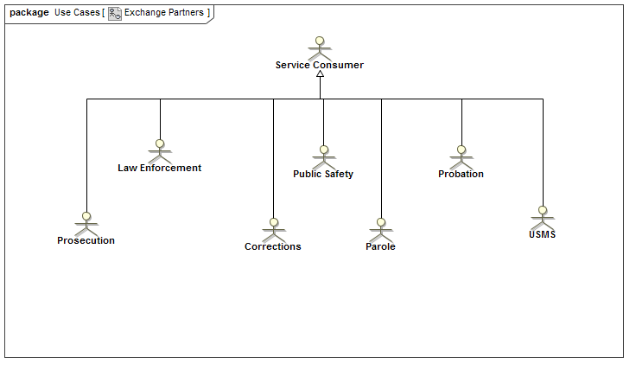
Figure 3 Actors

Use cases
The real-world effects of services are modeled as UseCases involving Actors. Each UseCase (oval) is a real-world effect and a business interaction. Each association between a UseCase and an Actor may be marked with a stereotype to indicate whether the Actor is a «Provider» or «Consumer» of the service. Figure 4 shows a simple example.
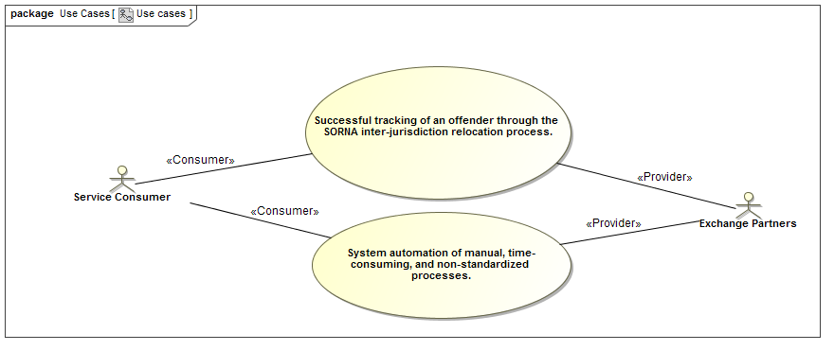
Figure 4 Use Cases

Interfaces
UML Interfaces define the operations and signal receptions that service providers implement to expose a service. The arguments of operations directly reference NIEM-UML message types as their content. Figure 5 shows a simple example.
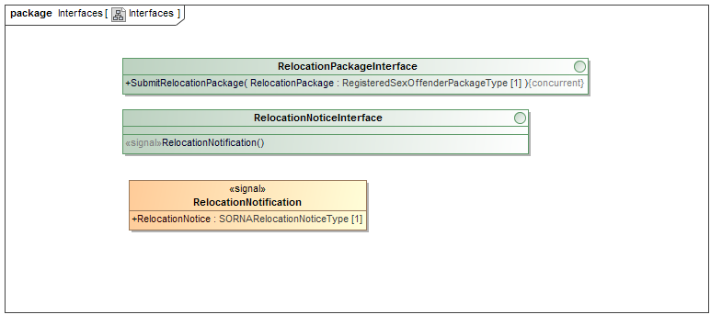
Figure 5 Interfaces

Components and ports
UML Components represent the service provided by an Actor. Each Component has a set of Ports that provide or use UML Interfaces. A Component may realize an Actor, to signify in the model that it represents the services provided by that Actor.
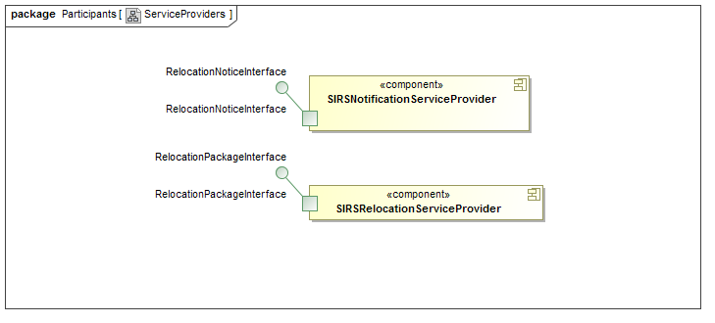
Figure 6 Components and Ports

Collaborations & Interactions
Collaborations are used to define the community for which the SSP is intended, providing a property for each Actor and service Component playing a role in that community.


Figure 7 Collaboration
The Collaboration that represents the community owns a set of Interactions that define the choreography of exchanges between the Actors to implement the UseCases. Figure 8 shows examples.
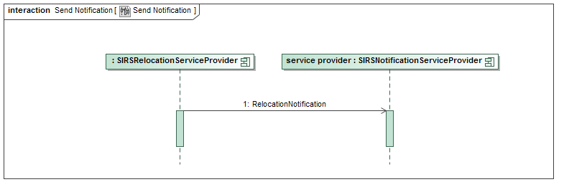
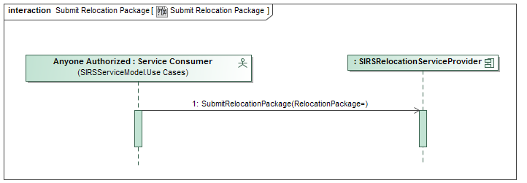
Figure 8 Interactions

The GRA Annotation Library

Overview
The GRA Annotation Library performs two roles in the overall workflow, and hence exists in two similar forms that differ in their details. The two forms are called the Modeling Library and the Intermediate Library. Both libraries contain the same UML classes and enumerations, with a few additional classes in the Intermediate Library. The Modeling Library is designed to simplify the modeling task by avoiding duplication of information and assuming that defaults are applied wherever possible. The Intermediate Library is designed to provide a convenient representation for consumption by phase 2, which uses XSLT. So, for example, instances of the Intermediate Library are nested and avoid cross-references, whereas no such restriction applies to the Modeling Library.
The purpose of the Modeling Library is to provide the ingredients for the end user to model the GRA-specific metadata needed for generating the SSP. The end-user accomplishes this by creating UML InstanceSpecification elements that instantiate classes in the Modeling Library.
Note: For readability in describing the use of the annotation library, the word “instance” will be used to mean UML InstanceSpecification, unless this interpretation would cause confusion.
Having created instances, the user gives values to properties in those instances, links them together, and provides Realization dependencies between specific instances and elements in the Logical Service model, and Usage dependencies to the Information Model.
The purpose of the Intermediate Library is to act as a metamodel for the intermediate annotations.xmi format. The phase 1 provisioning transformation consumes the end-user’s model created using the Modeling Library, and creates additional InstanceSpecifications, links and property values that represent all of the annotations needed to generate the SSP. The resulting model is then serialized as XMI in OMG EMOF format, where each UML InstanceSpecification is serialized as an EMOF instance, and UML links and slots serialized as EMOF properties.
Although it would simplify this specification if these two libraries were identical, this would place an additional burden on the GRA-UML modeler to know about and ignore those elements that are only used in the Intermediate Library. The authors of GRA-UML consider this burden to be excessive, and hence have decided to keep the libraries separate, although for convenience they are both documented together in Clause 9 of this specification.
The pivotal class in the Modeling Library is ServiceDescription. The user creates an instance of this class to represent the overall service description which then leads to the creation of an SSP. This ServiceDescription instance should be related to a Collaboration in the Logical Service Model by a UML Realization, signifying the community that the ServiceDescription relates to. It should also be related to the corresponding information model – a NIEM-conformant IEPD – by means of a UML Usage. Linked to the ServiceDescription is a set of instances that represent the metadata describing capabilities, requirements, exchange partners and so on; these instances, together with the properties of the ServiceDescription instance, are used to drive generation of the SDD documentation.
Accompanying the ServiceDescription instance are ServiceInterfaceSpecification instances that correspond to the Service Interfaces of the SPP. Each of these has properties and related instances that carry metadata to drive the generation of documentation. It also has related Service instances and a ServiceInteractionProfile instance that together drive the generation of WSDL schemas. As far as possible, default generation rules are applied, so that the user only needs to model exceptions from the default situation.
<Insert an explanatory diagram of a subset sufficient for this clause’s explanation>
The next three subclauses explain the differences between the two libraries. Clause 9 contains full documentation of the libraries.

Derived properties
Many properties in the intermediate model are derived by phase 1. For example, the property GRAServiceAnnotationBase::ModelReference is derived for any instance that has a Realization to an element in the Logical Service Model. The type of this property is the class ModelReference, which encapsulates a set of metadata used to identify and describe the realized logical service element. This property is derived by phase 1 and emitted into the intermediate annotations.xmi for consumption by phase 2. The Modeling Library contains neither this property nor the type ModelReference: all the modeler needs to do is create the correct Realization.
Another example involves Documentation properties. In the user’s model, text may be entered as documentation into a comment attached to the annotation instance: many UML tools distinguish the first comment of a model element through a special documentation field in the user interface. Alternatively the appropriate documentation might be found as a comment attached to a logical service element realized by the annotation instance. Either way, phase 1 extracts the text from the appropriate comment and places it into a derived Documentation property for the phase 2 XSLT to consume.
Clause 9 indicates all of the properties that are derived by phase 1, together with specifications of their derivations.

Compositions
XSLT transformations work best on hierarchically-structured documents, and phase 2 is an XSLT that consumes the output of phase 1. So the intermediate form is designed to be hierarchical, and this is represented in the Intermediate Library by numerous compositions. From the modeler’s perspective, however, it may be inconvenient to structure the annotations hierarchically: the same annotation may be shared between several elements, and this is most simply represented simply by linking them together. So in the Modeling Library there are no compositions; one of the tasks of phase 1 is to duplicate annotation elements shared in the user’s model so that they are hierarchically represented in the intermediate model.
An example of this approach is the property GRAServiceAnnotationBase::InteractionRequirements. This allows the attaching of an instance of InteractionRequirements at any level of the model from the complete ServiceDescription down to the individual Message. This instance provides a bundle of metadata specifying interaction requirements for the element to which it is attached. The user might share a single instance of InteractionRequirements amongst, say, a set of Operations; phase 1 processing would replicate that instance so that a copy is hierarchically contained with the metadata for all of those operations in the intermediate annotations.xmi.
Clause 9 specifies where these compositions differ between the libraries.

Service hierarchy defaults
The representation of service metadata in the intermediate file is strictly hierarchical: Service – Port – Interface – Operation – Parameter – Message. This corresponds with elements in the Logical Service Model: Component – Port – Interface – Parameter. A Service in the annotation model must realize a Component in the LSM. However it is not necessary for the user to construct the corresponding hierarchy of annotations corresponding to the complete LSM: phase 1 does that, and will provide typical metadata annotations for every element in the hierarchy. So in the simplest case the user only needs to specify the Service annotation, and everything else will be generated from the structure of the Logical Service Model.
For more control the user may override what phase 1 does, by providing explicit annotations and defaults.
The user may create a corresponding explicit hierarchy of annotation instances: Port, Interface, Parameter, Message, where each annotation instance must connect via a Realization to its corresponding element in the LSM. In this case, phase 1 will use the explicit annotations wherever they are provided.
Alternatively, the user may create default metadata for any of these elements. These are modeled using properties called PortDefault, InterfaceDefault, OperationDefault, ParameterDefault and MessageDefault, which can be set by the user on any higher level of the hierarchy – so for example an OperationDefault can be specified for a Port, but not vice-versa. If there is just one such default set on an element, and that default is not marked to realize anything, then that default metadata will be expanded for every corresponding subsidiary element in the intermediate file. A default may also be marked to realize a particular LSM element, in which case that default will be expanded as annotations for only that realized element and its subsidiaries: so, for example, if a “Port-A” has a MessageDefault instance that realizes “MetadataMessage”, all uses of “MetadataMessage” will utilize that MessageDefault value in any operation in any interface within the context of “Port-A”
None of these default properties appear in the intermediate annotations.xmi, since they would have have all been expanded in phase-1. The actions of phase 1 also cause some differences in lower multiplicity bounds between the Intermediate and Modeling Libraries: where zero elements are required from the modeler, at least one element may be required in the intermediate form. All of these differences between the libraries are specified in Clause 9.

GRA-UML Logical Services Profile

UML subset
Formal definition of the subset. For each UML metaclass included, define how it should be used in the PIM and how its properties are consumed by the various transformations.

Stereotypes
Define the two stereotypes.

GRA Modeling Library

GRA-UML Transformations

SSP workflow and structure
Explain how all the transformations fit together in an overall workflow and resulting folder structure.

Catalog.xml
Specify catalog schema and metamodel. Note: metamodel includes tool-specific extensions annotating the metamodel to enable XML document generation and representation of the XML type library.
Specify QVT. Describe the action of the QVT in a readable way (Tom?)

Metadata.xml
Specify metadata schema and metamodel. Note: metamodel includes tool-specific extensions annotating the metamodel to enable XML document generation and representation of the XML type library.
Specify QVT. Describe the action of the QVT in a readable way (Tom?)

Annotations.xmi
Explain the rules for populating the annotation model from the PIM + the modeled annotations. (Tom)
Explain how XMI is generated from the annotation model as an EMOF instance.
Specify QVT. Describe the action of the QVT in a readable way (Tom?)

SDD
Using XSLT to generate SDD XHTML from the annotations.xmi. Describe the action of the XSLT in a readable way.

SIDD
Using XSLT to generate SIDD XHTML from the annotations.xmi. Describe the action of the XSLT in a readable way.

WSDL
Using XSLT to generate WSDL from the annotations.xmi. Describe the action of the XSLT in a readable way.

GRA-UML Examples

(informative)
Cory to make up an illustrative example.

Mappings to other specifications

(informative)
Will be provided in revised submission.

Machine Readable Files

List and describe all of the machine readable files: name, purpose, normative/informative/ancillary.

Document revision history

(to be deleted before submission)

Date | Version | Editor | Change
5/2014 | 0.1 | Steve Cook | Initial skeleton template
6/12/2014 | 0.11 | Steve Cook | Filled out headings and sketched content
6/18/2014 | 0.12 | Steve Cook | A few comments; added annexes to TOC
7/01/2014 | 0.13 | Steve Cook | Minor changes
7/02/2014 | 0.20 | Steve Cook | Made a start on clauses 1 - 7
7/03/2014 | 0.21 | Steve Cook | Clauses 7.1, 7.2 and some of 7.3
7/07/2014 | 0.22 | Steve Cook | Clause 7.3
7/22/2014 | 0.23 | Steve Cook | Clause 7.4 and some rearrangement

